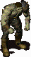
Fallout 2: Races Mod

Main
The player should have the option to play the game as one of the various 'races' within the fallout world. Each race should have different strengths and weaknesses to alter gameplay while maintaining game balance. Suggsested races are human, ghoul and super mutant.

Outline
At the end of the temple of trials the player has the option to choose one of three different paths, each path will give the player the option of a different race. The player still starts the game as a human but can choose to stay a human or mutate themselves into a different race to help aid their quest as the chossen one to find the GECK.
Path of the Vault – Human Path
This option just plays out like normal with the player opting to take up the vaultsuit and remain human, the normal vaultsuit movie is played.
Path of FEV – Super Mutant Path
It turns out that the Vault Dweller kept a vial of the FEV virus in case there was ever and emergency so great that the tribe could use this to transform a champion to save the village. If the player selects this path of then he infects himself with FEV and turns into a Super Mutant.
Path of Radiation – Ghoul Path
The Vault Dweller also aquired a small ammount of a radioactive compound from the city of necropolosis, this compound said to be the remnents of an atomic bomb is encased in a lead box. The player can open the box and expose them self to powerful gamma-x radiation within mutating them into a ghoul.

Clips
Once the player has made their choice and selected either the vaultsuit, fev or the radioactive compound the relevant movie clip will be played. The clip is changed using the sfall set_movie_path command.

Vsuit.mve fevdip.mve ghoul.mve
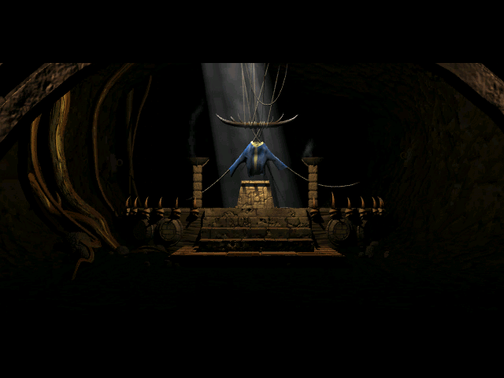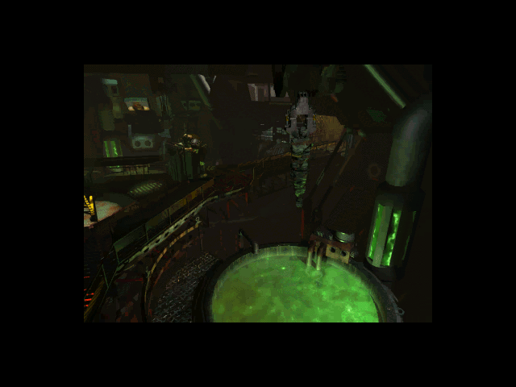

Models - default
After the movie has finished the engine will switch from using the start model to using the default model. The model is changed using the sfall commands set_dm_model and set_df_model depending on the players gender. The mutant and ghoul models are androgonous so are the same for both male and female characters.

hmjmps hfjmps mamtnt * naghul *

* these may be substituted for fallout tactics models.
Models - armour
Each race will need to have different armour types to reflect the different body sizes and ingame models. The obj_dude script will check the characters race to see if they are able to use the giving armour types. Rather than edit all of the existing scripts for stores and edit all the inventories to balance out the armour types it may be quicker and more realistic to just include TeamX's Mr Fixit mod so that the player can modify existing armour in the game to fit their player.

if (obj_pid(critter_inven_obj(dude_obj,INVEN_TYPE_RIGHT_HAND)) == PID_10MM_PISTOL) or
(obj_pid(critter_inven_obj(dude_obj,INVEN_TYPE_LEFT_HAND)) == PID_10MM_PISTOL) then begin inven_unwield(dude_obj);
end

Mutant Leather Armour
The player will require one leather jacket and one leather armour plus a knife. The player will use the Mr Fixit interface to combine the two armours into one suit of Mutant Leather Armour. Combining the MkII versions of the armour will make a MkII version.

mamtn2
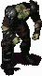

Mutant Metal Armour
The player will require one metal armour and one combat armour plus tools. The player will use the Mr Fixit interface to combine the two armours into one suit of Mutant Metal Armour. Combining the MkII versions of the armour will make a MkII version.

malieu
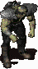

Weapons
Once the player has transformed into a mutant, they can no longer use small arms as they have big meaty hands and fingers (also there is no art for this). There are also no melee weapons so maybe mutant prefer to just club people up close.

if (obj_pid(critter_inven_obj(dude_obj,INVEN_TYPE_RIGHT_HAND)) == PID_10MM_PISTOL) or
(obj_pid(critter_inven_obj(dude_obj,INVEN_TYPE_LEFT_HAND)) == PID_10MM_PISTOL) then begin inven_unwield(dude_obj);
end

Problems
The main problem is the missing Frm sets for the melee and small arms attacks, it may be possible to edit the existing attacks to get an attack type for these, but it probably easier to just remove usage by scripts and write into the story that muties don’t use these types of weapons.

Perks
Since each race has different abilites such as damage resistance, strength and constitution. These can be assigned directly by script or using the sfall commands for modifing and using the unused perks from Fallout 2. A new perk that applies the character attribute changes is a nicer looking way to manage which race the player belongs to. It may be nessacary to give bonus points at level up to balance the game for some races.

Human Super Mutant Ghoul

Dialog
Player goes through temple of trials like normal and then gets to the very last part of of the temple where he talks to Cameron, this is where the mod begins. Cameron has added dialog that talks about the different paths the player can take to fullfill his roll as the chossen one, and how each path is different (human, mutant, ghoul). Cameron will explain that the player can take the Vault Dwellers suit, infect himself with FEV or expose himself to radiation. The choice is in the next room but first the player must prove himself worthy. The player then goes on to fight or talk to camaron out of fighting like normal, the player can now procede past the door.

Mapping
Now the player opens the door but instead of the movie playing when the player steps through, a large new room is present. The room contains the vaultsuit suspended between two pillers, a primitive lookin well full of a green goo (FEV), a small box of Radioactive compound on a pedistal. There should also be a new exit grid at the back of the room. Though this is only used so the player has a back way into the temple of trials.

***New art required***

Scripting
When the player uses any of the three items in the room a dialog window will pop up like when using a computer, it will state which path the item is and if the player wishes to procede down that path. Once the player choses to go down a certain path it will set the the following sfall variables and award the relevant race perk.
Human set_dm_model = hmjmps
set_df_model = hmjmps
set_movie_path movie4 = vsuit.mve
set_obj_dude_race = human (new global variable)
Super Mutant set_dm_model = mamtnt
set_df_model = mamtnt
set_movie_path movie4 = fevdip.mve
set_obj_dude_race = supermutant (new global variable)
Ghoul set_dm_model = naghul
set_df_model = naghul
set_movie_path movie4 = radact.mve
set_obj_dude_race = ghoul (new global variable)
Requirements
MrFixit - http://www.teamx.ru/eng/mod/mrfixit.shtml
- used to create mutant armour

sfall - http://timeslip.chorrol.com/sfall.html
- used to changed default model, vsuit movie and alter unused perks

Conclusion
This should be enough to get the game going and prove that everything works as planned. I' will start doing the art work and stuff soon, by then I'll need some help with the scripting.

- Though we dont have to do this with perks, it might look nicer.
- We should just start with the Super Mutant and then allow for the ghouls later?
- Other modders may want to add new dialog options to NPCs the player will encounter.

